Introduction:

This guidance is written for helping those who want to access the cluster/workstation for work (but can not access the SIR network directly). By reading this guidance, readers should be able to access and use the cluster resources easily.

How to access the cluster?

1. To access the jump server

If you can access the SIR network directly, skip this step

For some reasons, the cluster of SIR & the workstations in this cluster don’t have a public IP address. Therefore, it’s hard to access them directly. To solve this problem, we need to find some machines which can be accessed by an external machine and can access the target workstation as well to access instead.

Here, we provide a jump server by using a famous tool called “teamviewer” which is the most useful solution for this situation. To access the jump server for a further use, an installation of teamviewer client at local machine is needed. You can find the newest available version on the official download page of teamviewer.

<https://www.teamviewer.com/zhcn/download/>

After the installation, launch the application, we can have a user interface like this.

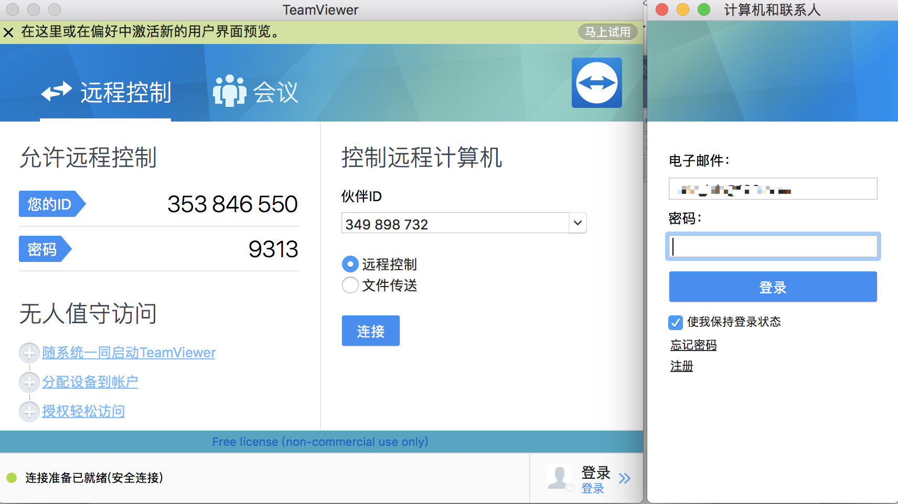

Teamviewer uses a technology that creates a virtual network which is not limited by the real network environment. In this virtual network, each instance can obtain a virtual IP so that they can visit each other in this virtual network by using the protocol made by teamviewer.

There are 2 ways to take part in a teamviewer virtual network. At this situation, we use the 2nd way to achieve our target. We added the jump server into a common teamviewer account, which means this jump server is in the virtual network organized by this teamviewer account. You can find & access this jump server after you logged in in the teamviewer client using the common account we provided.

For safety, we didn’t write the account & pwd here. Please contact our system administrators for further technical support.

2. To access the workstation

As common sense, we access the workstation by using ssh method.

If the jump server is used, a tool is needed since the OS of the jump server is windows and therefore we need a extra tool to create a ssh connection. You can find a application named “XShell” on the desktop.

To establish an ssh connection, we use command “ssh [username]@[address]”. Here, username will be provided by system administrators, and the IP address sometimes changes.

For now, the workstation IP address is 172.16.60.47, and the ssh port we use is the default ssh port(say, 22). If you need a user to access this workstation, or have any other relative questions, please feel free to ask the system administrators by wechat: thoh_testarossa